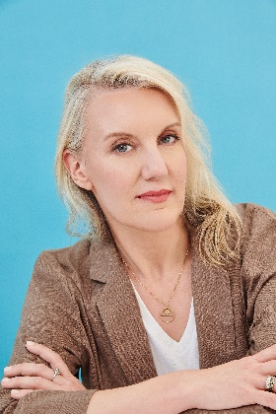
A conversation with Ada Calhoun, author of
CRUSH

Viking | On Sale: February 25, 2025

Your debut novel is about marriage, midlife, and what happens when the overwhelming desire of a crush upends both. Would you tell us more about CRUSH and your inspirations for the novel?

Crush is about a happily married woman who develops a crush on a friend of hers and tries to figure out how to stay close to him without destroying her marriage. She and this friend, who’s a professor, basically ransack the entire history of world literature looking for advice on how to protect her marriage without ignoring their profound connection. Crush is fiction but it’s also a sequel of sorts to earlier books of mine. In writing my memoir, Also a Poet, I came to believe that I had to stop working so hard to be “good.”

You share some similarities with your narrator in CRUSH. How did the novel evolve from, and beyond, your own experiences?

Yes, like some of my favorite novels—Nora Ephron’s Heartburn and Sigrid Nunez’s The Friend, for example—my narrator is like me in a lot of ways. But what was great about writing fiction was I could make everyone behave however I wanted them to. I enjoyed adding characters and scenes and giving the narrator this perfect, life-altering love interest. Writing memoir I would get frustrated sometimes because the people around me weren’t acting in a way that was convenient for the plot. Fiction solved that problem.

How do you see the narrator’s story reflecting broader conversations about love, desire, and commitment in today’s post-pandemic society?

When I wrote my New York Times bestseller Why We Can’t Sleep and the article that became that book, “Women’s New Midlife Crisis,” for Oprah.com, I talked to hundreds of women who said they were overwhelmed and exhausted and having fantasies of blowing up their lives. Then, in the worst way, the pandemic blew it up for them. While it made some things much harder on these women (like caregiving and job instability), it also gave them this opportunity to stop and ask big questions, like, Why am I doing everything? What if I just… do what I want?” As soon as the narrator begins asking those questions in earnest, everything starts to change.

For all that CRUSH explores, our narrator’s name is never revealed. What was appealing about having an anonymous narrator?

For me, reading fiction usually means projecting myself into the story. So I personally enjoy a narrator who’s sort of a blank slate. This book’s been compared to Miranda July’s All Fours (which is flattering because I really enjoyed it!), but one person told me, “When I read that book, I thought about Miranda July, who’s this very singular character; when I read this book, I thought about myself.”

You’ve ghostwritten a lot of big books. While I know you can’t talk about them because of the nature of the job, can you share how that work relates to what you talk about in CRUSH?

When I’m helping someone write a book it often feels like having a crush on them. Helping someone tell their story, you often wind up with that crush-like enthusiasm where you want to get inside their head and know every last thing they’re thinking and how they think it. It can be similarly intoxicating. I often dream about the people I collaborate with, and I always dream about my crushes.

What do you hope readers take away most from CRUSH?

Crushes can reveal what we long for in our lives. Especially as women who’ve pushed down our own desires in the course of taking care of others, I think we should listen to our longings. We don’t need to always act on them, but I think it’s important to admit what they are, and to let ourselves have whatever kinds of love we want that become available to us, whether that’s romantic love, maternal love, the love of friends, or more surprising or nebulous kinds of love, like crushes or pen pals. Like me, the narrator spent most of her life as a teacher’s pet, working hard, taking care of other people, and trying to be responsible and considerate. Without becoming unkind or cavalier, she learns in the course of the book that some things are more important than goodness.

